

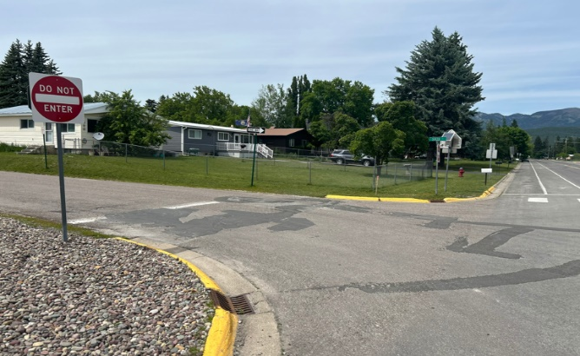
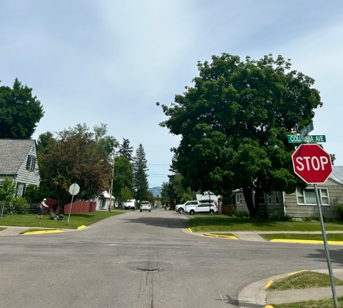
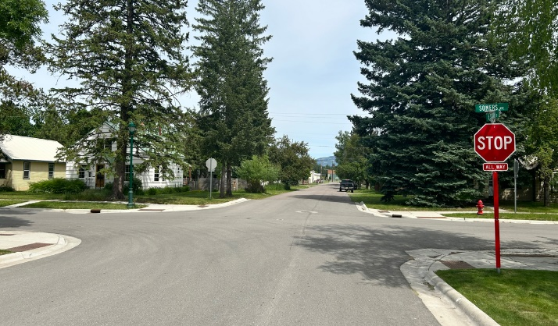
CITY OF WHITEFISH
EAST 6TH STREET RECONSTRUCTION PROJECT
Project Questionnaire

Name:
Mailing Address:
Physical Address:
Email Address:
Phone Number:

Do you rent or lease your property? YES NO
If yes, please provide the tenant’s name and contact information:
Does your property have a sump pump, or do you deal with high groundwater?
Does your property have an irrigation system? YES NO
.
Anyone in your household attend Whitefish High School or Muldown Elementary School?
YES NO
.
Do you have any thoughts or concerns about the reconstruction of E. 6th Street or sidewalk installation along Pine Avenue?

